**Smoke detector and flammable gases**

1. Wiring diagram

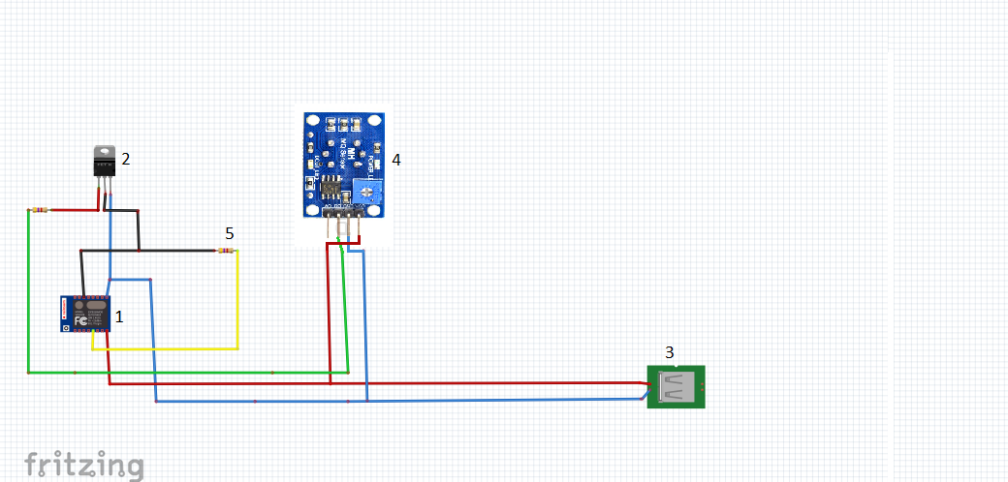

1. The necessary elements

1. ESP 12e nodemcu v3

2. Bc557 NPN

3. USB (5V)

4. MQ-2

5. Resistor(4.7kΩ)